**Probability** **and Statistics**

**Lab 06  
IT24100800  
Rajapaksha AGS**

**Exercise**

1. **i)** Binomial distribution (*n*=50,*p*=0.85)

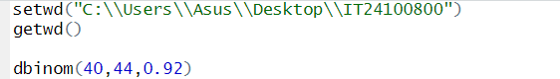

**ii)**

1. i) Number of customer calls received in an hour  
   ii) Poisson distribution

iii)

